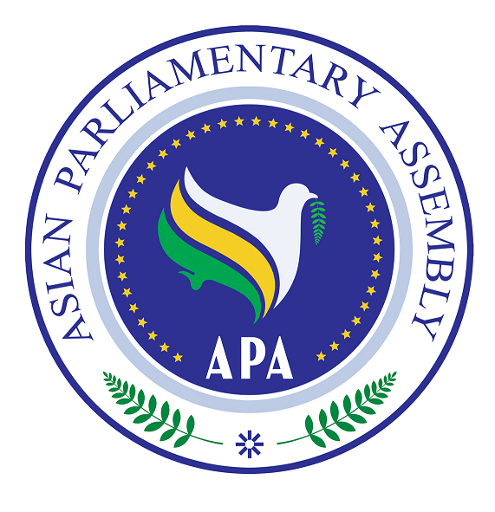  Asian Parliamentary Assembly (APA) | REGISTRATION FORM  Participating in APA Cooperation and Coordination Meeting  At the side of 135th IPU Assembly  15.00-16.00 hours on Sunday, 23 October 2016.  Room 18 – Lower Ground Floor of CICG at the Venue of IPU Assembly.

Please fill in Capital Letters, one form for each individual participating delegate and return to APA Secretariat by 15 October 2016.
- Delegation of: …………

- Title (please check Mr. Ms. Dr., etc.)
- First Name:
- Last Name:

- Position, in the parliament
- ……………………………………………………………………………………

- Phone No. | - …………………..……………………………………………..  - Country Code - City Code - Number
- Mobile No.  - Fax No. | - …………………………………………………………………  - ………………………………………………………………..
- Email Address: | - ……………….……………………………………………..

Any Proposal on Emergency Item:

Please return to APA Secretariat:
Email : secretariat@asianparliament.org
Fax: 009821 - 26118809

